

APPLICATION FOR FOOD TRADE SITE

2023 FESTIVAL

Saturday 25th of February 2023

Village Green, Heywood, Victoria 3304

Hours of operation: 10am – 10pm

Dear What’s-ya-name,

Please find enclosed an application form for a food trade site at the Heywood Wood, Wine & Roses Festival to be held on Saturday 25th of February 2023.

Each site is approximately 6 metres wide by 4 metres deep. Site fees for the 2023 festival have been set at the following rates:
Food Trade Sites: $100.00
Powered Sites: $10.00 additional charge (limited power available)

Each stall will be issued with one complimentary gate pass, and one additional pass is available for $5.00. If required, additional passes are available at a cost of $25 per person.

The Festival Gates open at 7am, please stay and trade until at least 10.00 pm

For setup purposes, it would be appreciated if stallholders could set up on the Friday beforehand as there is plenty of security at the festival site during the night.

As there are a limited number of sites available, the attached application form and site fee/s must be returned before Friday 16th December 2022 to secure your site at the festival.

Yours faithfully

Coreen Barclay
Stallholder CoOrdinator
Phone/fax (03) 5527 2034
Mobile 0428 342 287
Email: markets3304@gmail.com

APPLICATION FOR FOOD TRADE SITE

2023 FESTIVAL

Saturday 25th of February 2023

Village Green, Heywood, Victoria 3304

Hours of operation: 10am – 10pm

Business Name: __________________________________________
THIS NAME WILL BE REGISTERED BY THE ORGANISERS AND SHOULD BE QUOTED ON ARRIVAL FOR ASSISTANCE IN SITE ALLOCATION

Contact Person: _______________________________________________
Address: ___________________________________________________
Town/Suburb: ________________________________ Postcode: ________
Contact Phone No: ___________________Mobile phone: ______________
Email Address: ________________________________________________
Product Type: (a full description of all products being sold &/or service/s provided)
______________________________________________________________________________________________________________________________
Site size required: Standard (6m x 4m) Yes / No (other – please circle NO and give EXACT measurements needed below)

Other – please specify area needed (frontage x depth) ______________________
Number of sites required _______________
Extra passes - One at $5 ____________ Number at $25 each _____________
Other Requirements: (Tick if applicable)
Require Power (limited) Operating at night
Erecting own tent/gazebo Vehicle to be kept on site
Other Comments: ________________________________________________
______________________________________________________________

GENERAL INFORMATION

- Site Size:- All sites will be a standard size of 6 meters frontage x 4 meters deep unless otherwise specified on the application form.

- Food Stalls: - $100 per unpowered site. Applications close Friday 16th December 2022.

- Retail Stalls: - $40 per unpowered site. Applications close Friday 20th January, 2023

- Powered Sites (food & retail):- $10.00 additional charge (limited powered sites available)

- Gate Passes:- One festival pass will be issued to the stallholder applicant. Stallholders may purchase one only extra pass for $5.00, any additional passes required will be charged at $25.00 each.

- As site numbers are limited and to ensure you obtain a site, the application form, and site fees must be received before the due date via the following methods.
- Post completed documentation along with the cheque made out to Heywood Wood Wine Roses Inc, to PO Box 82, Heywood VIC 3304
- Email completed documentation to markets3304@gmail.com and
- Direct Deposit payment to Heywood Wood Wine Roses Inc 633108 Account no 134406453 please reference your business name
- Please complete and return the compulsory Fire Brigade documents and return with application and stallholder fee.
- Refer to check list provided in the final page of the package.

- Site numbers and receipts will be posted / emailed approximately 2 weeks prior to the festival date.

- Please enter the festival site via gate 2 / Hunter Street east (south side of IGA).

- For setup purposes, it would be appreciated if stallholders could set up on the Friday before the event as there is plenty of security at the festival site during the night.

- For those who can’t setup the day before to the event, the festival site gates will open at 7am on the morning of the festival.

- All sites are to be setup by 9.30am. Sites are to remain open from 9.30am until late.

- All vehicles that are not contained totally within the site and are not an integral part of the display or stall, must be relocated to an approved parking area outside the town green prior to 9.30am.

- All food stallholders must have a working fire extinguisher on their site.

- All equipment must meet the Victorian Energy Safe requirements.

- All power leads need to be in good working order and be tagged.

- Any stallholder who is responsible for the safety switches being tripped, will have their power supply disconnected.

- The following items are banned from sale at the festival. There is no exception to this list: -
- Any firearm, replica firearm or toy guns of any description. (This includes water pistols and cap guns).
- Any knife or bladed weapon that is banned by state laws.
- Stink bombs and cans of silly string.
- Any other prohibited weapons / items that are banned by state laws.
- Please Note: Local police may be contacted if any breaches of state laws are detected by festival staff or security staff.

- No Dogs are allowed within the festival site. All Pets are excluded from the festival grounds due to Health and Safety regulations.

- No push bikes, roller blades, roller skates or skateboards are permitted on the village green during the event.

I have read the general information sheet and agree to abide by the conditions outlined.

Signed ______________________________________Date____________
-------------------------------------------------------------------------

Office Use Only:

Amount Received: $_____________ Date Paid: __________
Site Number(s) ___________________ Receipt Number __________
ACCOMMODATION LIST:

Should you be planning to stay overnight or longer, a list of available accommodation is listed. Any enquiries regarding accommodation should be directed to the accommodation providers directly.

Heywood Hotel 47 Edgar Street, Heywood Ph. (03) 5527 1803

Heywood Motor Inn 42 Portland road, Heywood Ph. (03) 5527 1703

Pinewood Caravan Park
Cameron & Rebecca 2 Bell Street, Heywood Ph. (03) 5527 1370

Bonnie View Holiday Farm
Alan & Alison Lepp 1 Pennys Road, Heathmere Ph (03) 5529 2313

Melaleuca Motel
Lynne and Phil Daly 23 Bentinck Street, Portland Ph (03) 5523 3397

Whalers Rest Motor Inn 8-12 Henty Hwy, Portland Ph (03) 5523 4077

Admella Motel 5 Otway Court, Portland Ph (03) 5523 3347

Mariner Motel 196 Percy Street, Portland Ph (03) 5523 2877

**************************************************************

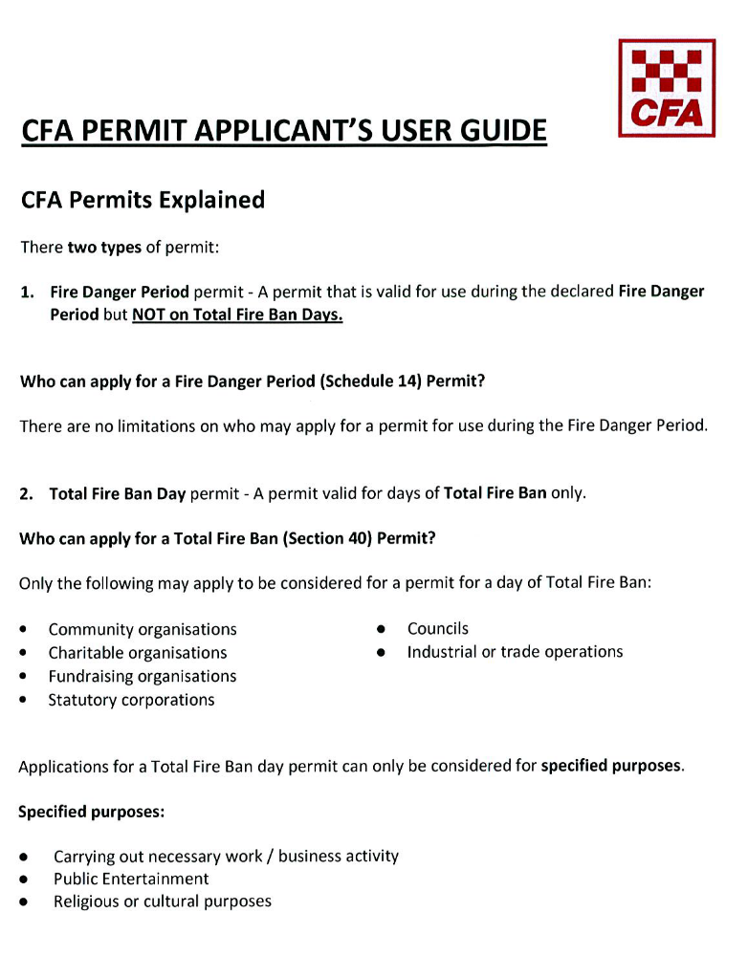

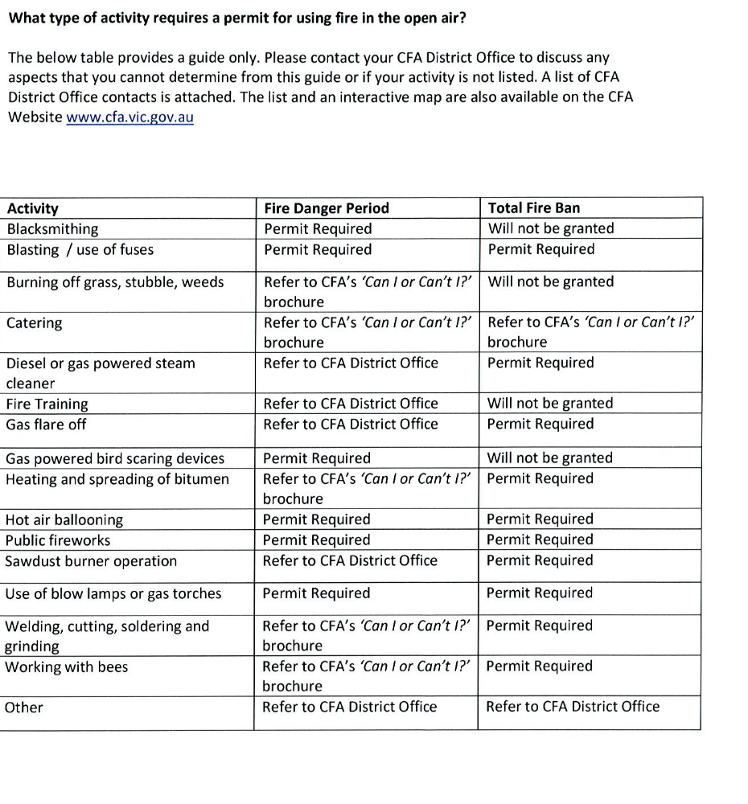
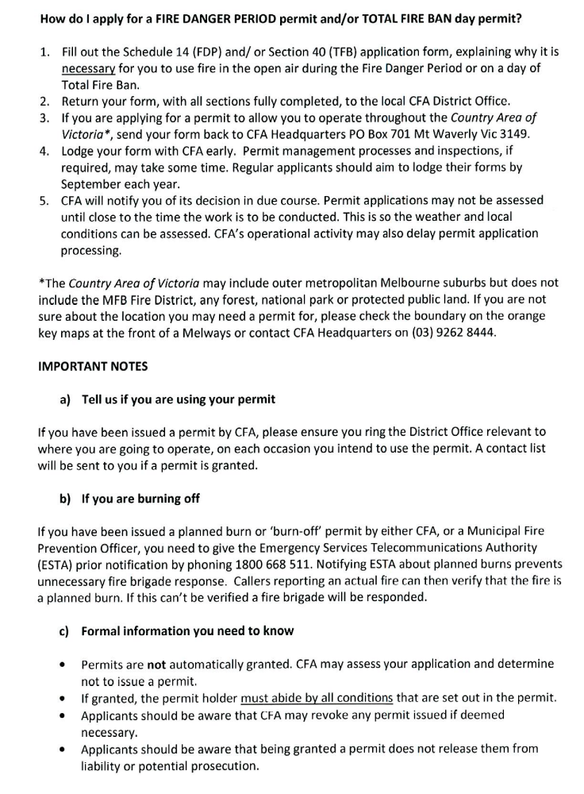
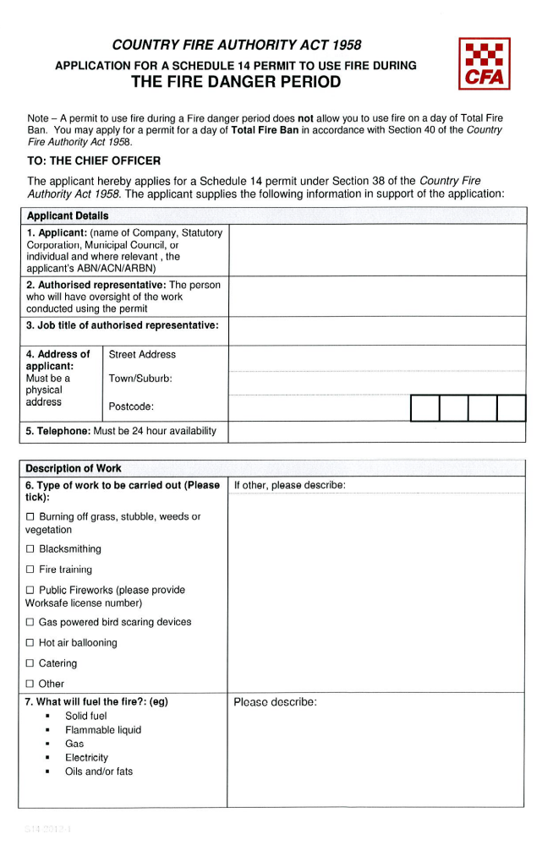
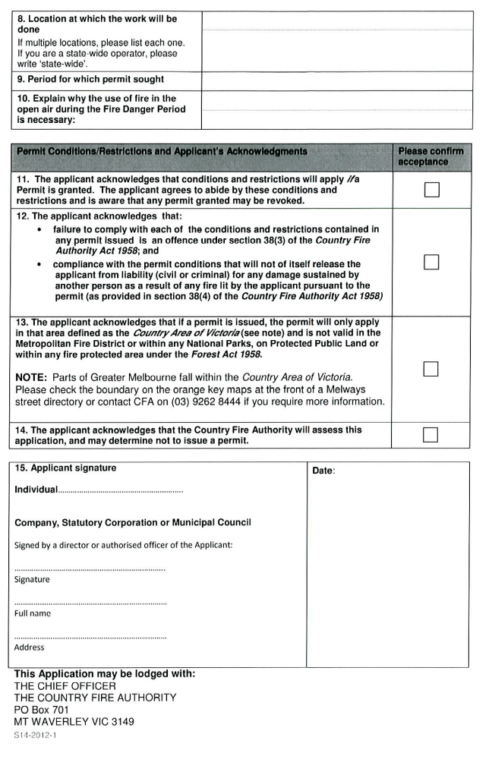
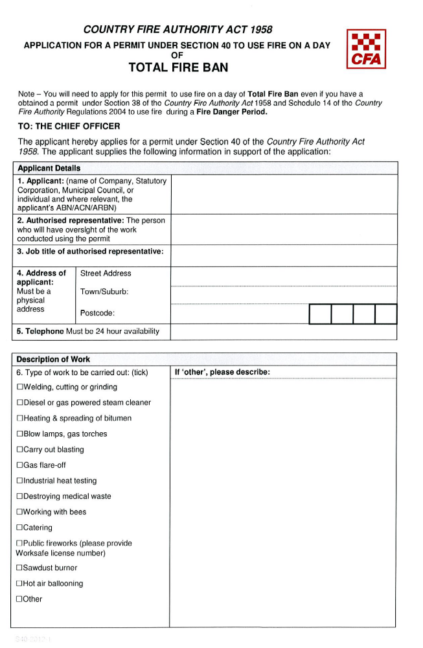
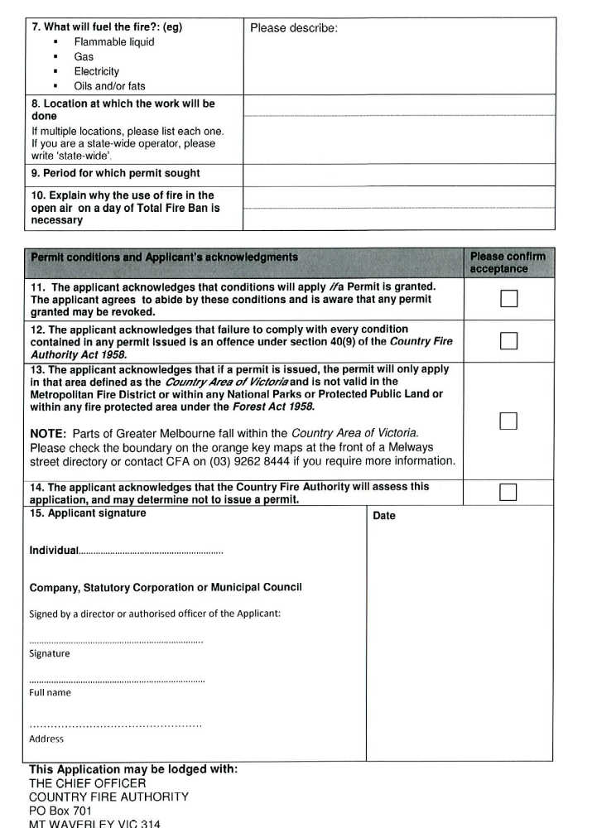

DOCUMENTATION CHECK LIST FOR FOOD STALLHOLDERS

  - Fire Brigade documents

  - Copy of Food Handlers Certificate

  - Copy of Public Liability Insurance

  - Copy of Acceptance of Mobile Food Van Gas Installation (if applicable)

  - Copy of Certificate of Renewal of Registration of Food Premises

